8 How to Copy and Paste Keyframes in DaVinci Resolve on Edit Page
~ Part 1~

Animate something in the Inspector
Start out on the Edit page, in the DaVinci app.

On the Cut page, you can find a tab for Titles, but on the Edit page, you have to go through a few more steps to get to it.
Effects- Titles
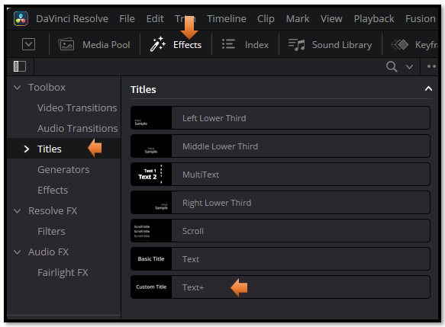
Watch It! before we add the text DaVinci insists on having a background layer. So, do this first.
Effects-Generator-Background
Watch it – It must be background to work, do not use something like sold color, you will not get anywhere. You can test it on the Fusion tab to make sure that your nodes showed up. You must have nodes – Background - MediaOut1
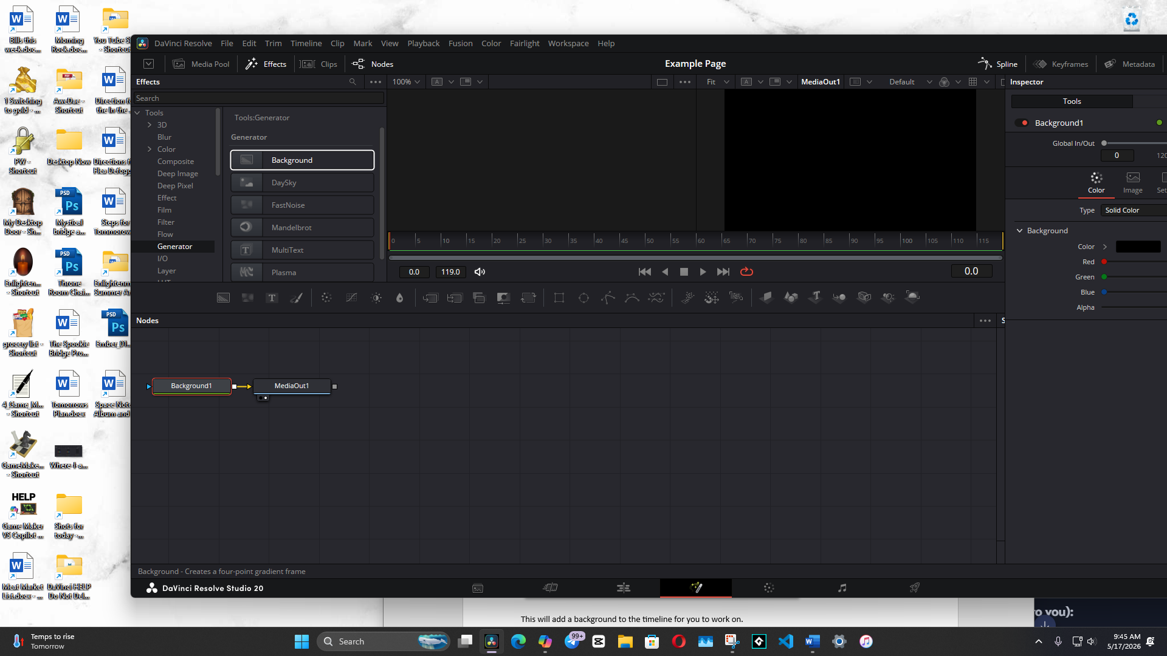
This will add a background to the timeline for you to work on.
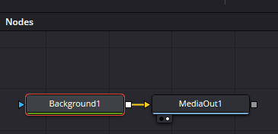
Now you can go back to Titles in the Effect Panel
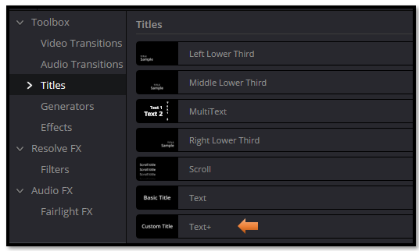
- Add a Text+
- Animate Center Y or Opacity
- Click the diamond to set a few keyframes
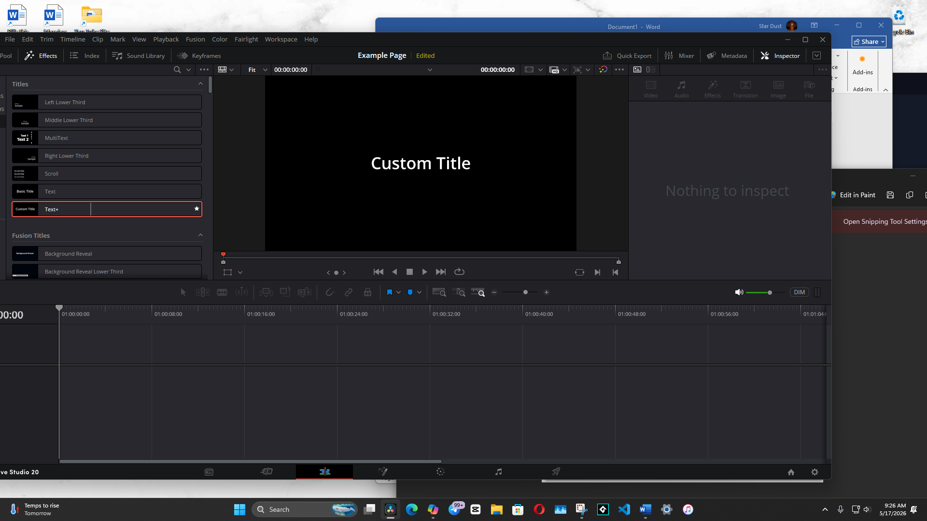

This gives you the material you need to demonstrate the copy/paste.

2. Open the Keyframe Panel
This is the part beginners always miss.
- In the Edit page
- Top-right of the timeline
- Click the Keyframe icon (looks like a diamond)
This opens the mini keyframe timeline under your clip.

3. Expand the clip’s keyframes
Click the little arrow next to the clip name so you can see:
- Transform
- Cropping
- Text
- etc.
Then expand the parameter you animated (e.g., Center).
Now you’ll see the diamonds.

4. Select the keyframes you want to copy
You can:
- Click a single diamond
- Or drag-select across multiple diamonds
- Or Shift-click to select specific ones
They will highlight when selected.

5. Press Ctrl+C
This copies the selected keyframes.

6. Move the playhead to the new location
This is important:
The Edit page pastes keyframes starting at the playhead, not relative to the original timing.
So if your original animation was 12 frames long, the pasted version will also be 12 frames long, starting wherever your playhead is.

7. Press Ctrl+V
Boom — the keyframes appear at the new location.
You can now:
- Slide them
- Delete them
- Add more
- Or copy/paste again

